EE101 Homework 3

**Please submit it via Blackboard Due：November 17th 23：59**

**TA’s Email:** [**zhanghb2022@shanghaitech.edu.cn**](mailto:zhanghb2022@shanghaitech.edu.cn)

**Your name: Student ID:**

**Problem 1: (30 pts)**

(1) Calculate the intensity transmission coefficient, $T_{I}$, for the following interfaces, assuming that the ultrasound beam is exactly perpendicular to the interface: (i) bone/brain, (ii) air/muscle, and (iii) fat/muscle.

(2) Repeat the calculations in (1) with the angle of incidence of the ultrasound beam now being $45°$.

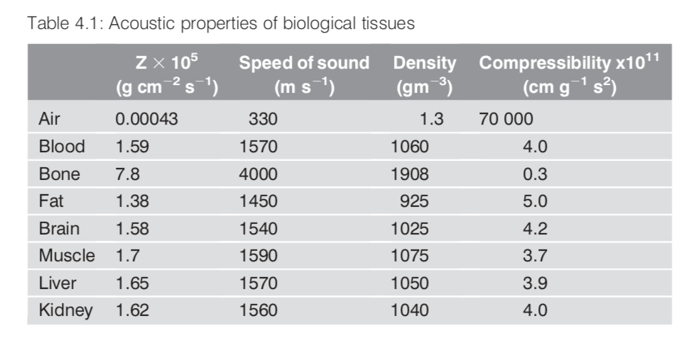

**Solution:**

(1) Since the ultrasound beam is exactly perpendicular to the interface, we say that this is a normal incidence case, and we can compute $T_{I}$ by

$$T_{I}=\frac{4Z_{1}Z_{2}}{{(Z_{1}+Z_{2})}^{2}}$$

We have the following results:

(i) 0.56028, (ii) 0.001, (iii) 0.9892. (15 pts)

(2) Since the angle of incidence of the ultrasound beam now being $45°$, first we need to compute the transmitted angles by

$$\frac{\sin{θ_{i}}}{\sin{θ_{t}}}=\frac{c_{1}}{c_{2}}$$

Then we could calculate $T_{I}$ by

$$T_{I}=\frac{4Z_{1}Z_{2}\cos{θ_{i}\cos{θ_{t}}}}{{(Z_{2}\cos{θ_{i}}+Z_{1}\cos{θ_{t}})}^{2}}$$

(i) For muscle/kidney interface, we have (5 pts)

$$\frac{\sin{45°}}{\sin{θ_{t}}}=\frac{4000}{1540}⇒θ_{t}=16°$$

$$T_{I}=\frac{4×7.8×1.58×\cos{45°}×\cos{16°}}{{(1.58×\cos{45°}+7.8×\cos{16°})}^{2}}=0.451$$

(ii) For air/muscle interface, we have (5pts)

$$\frac{\sin{45°}}{\sin{θ_{t}}}=\frac{330}{1590}⇒θ_{t} \text{is undefined}$$

So, there is total internal reflection and no signal is transmitted.

(iii) For bone/muscle interface, we have (5 pts)

$$\frac{\sin{45°}}{\sin{θ_{t}}}=\frac{1450}{1590}⇒θ_{t}=51°$$

$$T_{I}=\frac{4×1.38×1.7×\cos{45°}×\cos{51°}}{{(1.7×\cos{45°}+1.38×\cos{51°})}^{2}}=0.9979$$

**Problem 2: (20 pts)**

Calculate the distance at which the intensity of a 2 MHz and 10 MHz ultrasound beam will be reduced by half traveling through (a) bone, (b) air, and (c) soft tissue. (The frequency dependence of $μ$ is 8.7 dB/cm/MHz for bone, 45 dB/cm/MHz for air, and 1 dB/cm/MHz for soft tissue.)

**Solution:**

For the intensity to be reduced by half, the value of $μx$ must be ~3 dB. Therefore, we could compute the distance, $x$, by

$$x=\frac{3}{μ}$$

So, for 2 MHz ultrasound beam, (a) 0.172 cm, (b) 0.033 cm, (c) 1.5 cm.

And for 10 MHz ultrasound beam, the distances are one-fifth of those for 1 MHz, thus we have (a) 0.0345 cm, (b) 0.0067 (6*10^-3) cm, (c) 0.3 cm.

**Note:** *If you confused the intensity attenuation coefficient with the frequency dependence, half of the points will be taken. Remember that*

$$μ \left(\text{dB/cm}\right)=4.343μ ({cm}^{-1})$$

**Problem 3: (20 pts)**

If we only consider the transmission process of ultrasound wave and neglect the multiple reflection in different boundaries, please answer the following questions:

(1) Given values of $ZPZT$ and $Zskin$ of $25×{10}^{5} g cm^{-2}s^{-1}$ and $2.7×{10}^{5} g cm^{-2}s^{-1}$, respectively, calculate what fraction of the energy from the transducer is actually transmitted into the patient if one matching layer is used.

(2) If two matching layers are used instead of one, and the respective acoustic impedances are given by the analogues of the equation above, then calculate the increase in efficiency in transmitting power into the patient.

**Solution:**

(1) The value of ZML is given by:

$$Z_{ML}=\sqrt{\left(25×{10}^{5}\right)\left(2.7×{10}^{5}\right)}=8.22×{10}^{5}\text{gc}{\text{m}}^{\text{-2}}{\text{s}}^{\text{-1}}$$

The value of TI is now calculated:

$$T_{I}=\frac{4\left(25\right)\left(8.22\right)}{{\left(25+8.22\right)}^{2}}\frac{4\left(2.7\right)\left(8.22\right)}{{\left(2.7+8.22\right)}^{2}}=0.55$$

(2) If the two matching layers have Z values ZML1 and ZML2, then two equ15ations can be written to solve for these values:

$$Z_{ML1}=\sqrt{25Z_{ML2}}$$

$$Z_{ML2}=\sqrt{2.7\sqrt{25Z_{ML2}}}$$

These equations can be solved easily to give ZML1= ${11.91 × 10}^{5}\text{gc}{\text{m}}^{\text{-2}}{\text{s}}^{\text{-1}}$ and ZML2= $5.67×{10}^{5}\text{gc}{\text{m}}^{\text{-2}}{\text{s}}^{\text{-1}}$. Calculating TI across the two boundaries gives:

$$T_{I}=\frac{4\left(25\right)\left(11.91\right)}{{\left(25+11.91\right)}^{2}}\frac{4\left(11.91\right)\left(5.67\right)}{{\left(11.91+5.67\right)}^{2}}\frac{4\left(5.67\right)\left(2.7\right)}{{\left(5.67+2.7\right)}^{2}}=0.67$$

Increase = 0.67-0.55 = 0.12

**Problem 4: (30 pts)**

Sketch the Doppler spectral patterns at points 1, 2, and 3 below in a stenotic artery, which is shown in Figure 6, and explain briefly why. (All of the plots are made over one cardiac cycle.)

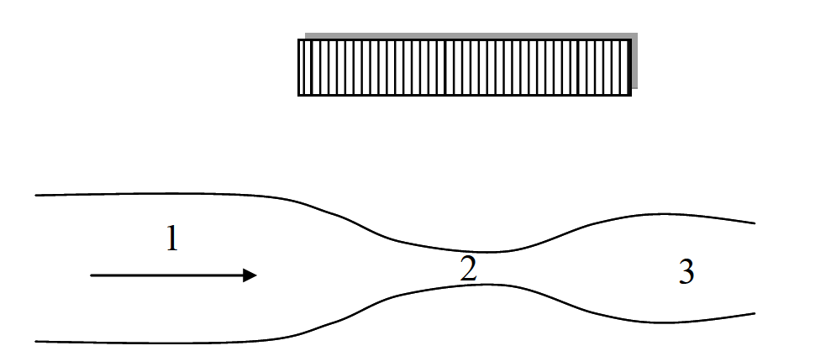

*Figure 6*

**Solution:**

At position 1 the flow is characterized by a range of relatively low velocities predominantly flowing towards the transducer. At 2, since the vessel narrows, the velocities become much higher. However, there are equal contributions from flow towards and away from the transducer, and so equal positive and negative frequencies. At 3, there will be a broad range of velocities, probably including turbulent flow. The Doppler spectral patterns will have the general appearance shown below.

